Nostalgia Time Capsule
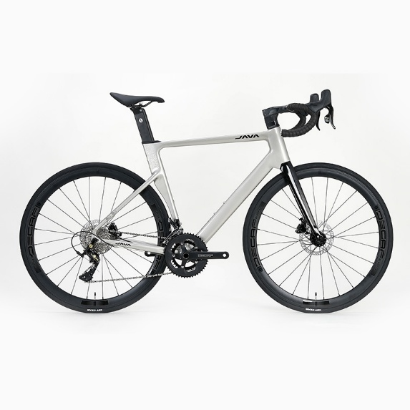
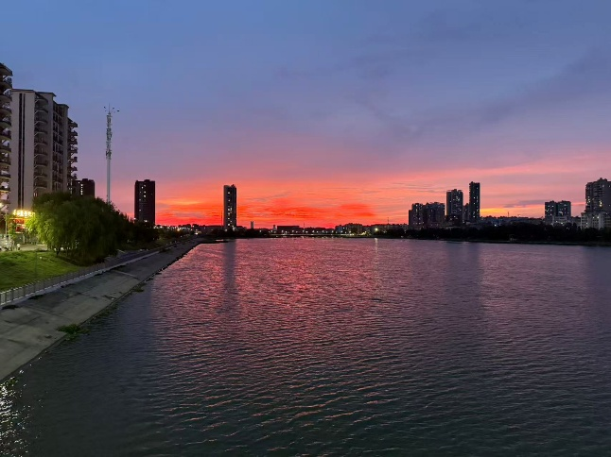
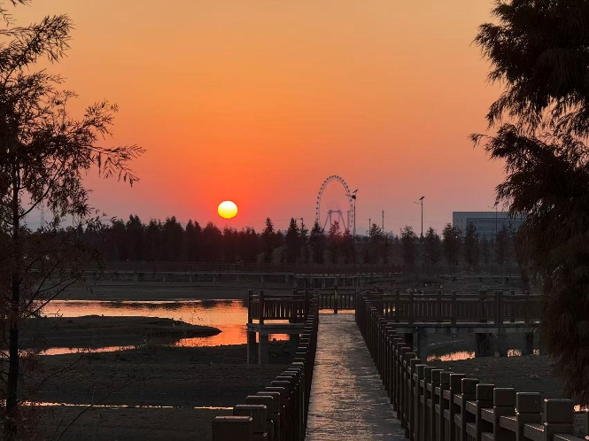
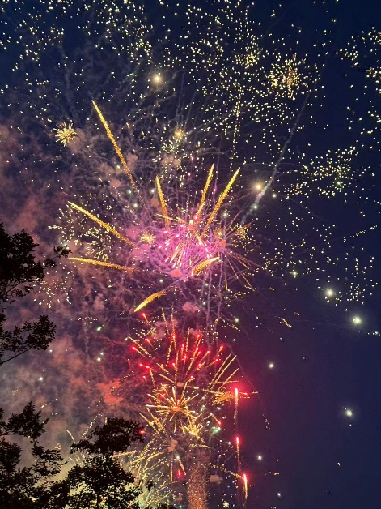
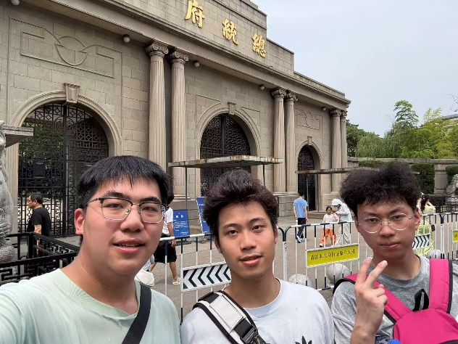
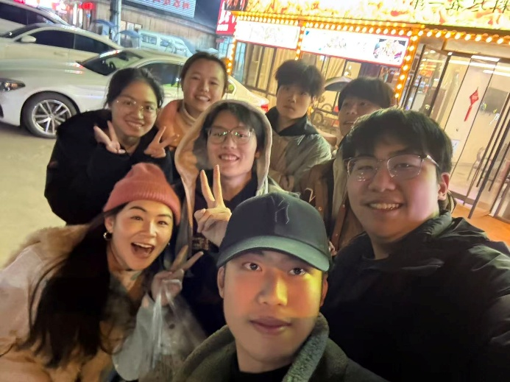
My hometown Wuhan
Riding a bicycle to school
Traveling with friends (Nanjing, China)
Having Chinese New Year's Eve dinner with my family
Fondness for my high school friends
Nostalgia for my favorite amusement park from childhood.
The rainbow in high school (makes me optimistic)
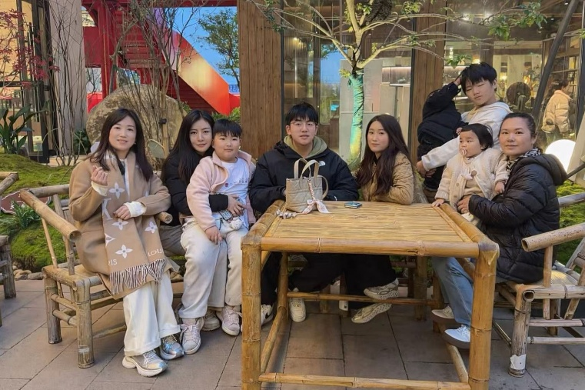
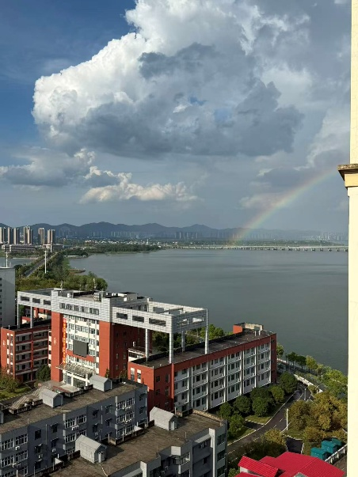

Summary
Creating my nostalgia time capsule helped me better understand my strongest feelings of nostalgia. Looking at photos of my favorite amusement park from childhood immediately brought back memories of a simpler, happier time. That place represents pure childhood memories and a carefree sense of happiness, which I deeply miss.
I also feel a strong fondness for my high school friends. The photo of us together reminds me of shared laughter and a feeling of belonging. Even now, thinking about those friendships brings warmth and emotional comfort. Traveling with friends in Nanjing, China was another meaningful experience that I often reflect on. Those trips strengthened our bond and created memories that still evoke nostalgia today.
My hometown, Wuhan, holds a special place in my heart. The sunset by the river reminds me of my roots. Riding a bicycle to school every day was an ordinary routine. These small moments now feel especially precious.
Finally, images of Chinese New Year’s Eve dinner with my family represent collective nostalgia. Gathering together, sharing food, and celebrating traditions gave me a strong sense of connection. The rainbow I saw in high school still makes me feel optimistic. It reminds me that nostalgia is also about hope for the future. This time capsule shows how revisiting these memories restores my enthusiasm and optimism as I move forward in life.

Works Cited
Bicycle

